Project Description
Project Name: Me don’t wrong
Group Members:
- Chanon Chiang 6631309921]
- Thukdanai Thaothawin 6631319121
- Thanaphat Intarapuk 6631324221
Problem Description: Chulalongkorn students who have a beef with a friend often can't resolve it — conversations get avoided or escalate over chat, leaving the conflict unresolved. We will resolve that for you.
Target Customers: Chulalongkorn students who have a beef with someone.
Scenario (use-case & description): Maya and Nina disagree about who borrowed the library headphones. Maya opens the app and signs in. She taps "Create Dispute", searches for Nina by name, picks her and describes the problem. The system saves the dispute and links it to both accounts, so only the two of them can see it. Maya writes her side and adds a link to her evidence, then sends it for analysis. Nina signs in, opens the same dispute, writes her side and sends it too. When both sides have arrived, the system asks an AI model and shows both of them a neutral summary, how each side sees it, what information is still missing and a proposed compromise.
Use Case 1: Create Dispute & Choose Opponent
- Actor: User A (dispute creator)
- Goal: Start a dispute and link it to the accounts of both people so that only they take part
- Flow: User A signs in → taps "Create Dispute" → searches registered users and picks User B → describes the issue → submits → the dispute is saved with A as creator and B as opponent → both see it in their dispute list
- Service: Dispute Service (Node.js, REST, SQLite)
Use Case 2: Submit Argument & Evidence
- Actor: User A and User B
- Goal: Let each person state their side with supporting evidence
- Flow: The user opens the dispute → writes a statement → adds evidence links (image, document or link) → saves it → can edit or delete it later. The system checks that the user is one of the two people in the dispute.
- Service: Evidence Service (ASP.NET Core, gRPC, PostgreSQL)
Use Case 3: AI Problem Resolution
- Actor: User A and User B
- Goal: Get a fair, neutral resolution without escalating further
- Flow: Each person sends their argument to the AI → the message goes through RabbitMQ → the AI waits until both sides have arrived → the AI analyzes both sides → a suggested resolution is stored and shown to both parties
- Service: AI Problem Resolution service (Python workers, RabbitMQ, MongoDB)
Authentication (supports all use cases)
- Actor: Any user
- Goal: Know who is acting and keep each dispute private to its two people
- Flow: The user registers or logs in → receives a signed token → every request carries the token → the services read the user identity from it
- Service: Evidence Service (users in PostgreSQL); the Dispute Service checks the token too
Public polling & commenting and betting from the first proposal are deferred to a later milestone.
Functional Requirements:
- Users can create a dispute and describe their side of the argument
- Users can invite an opponent (User B) to join a dispute
- Invited users can accept or decline a dispute invitation
- Users can submit arguments and evidence for AI analysis
- System uses AI to analyze both sides and suggest a fair resolution
- Users can accept or reject the AI's suggested resolution
- Users can open a public poll if the dispute remains unresolved
- Public users can vote on a poll and leave comments
- Users can place bets on the outcome of a dispute/poll (optional feature)
- System settles bets automatically once a dispute/poll is resolved
Non-functional Requirements:
- AI analysis and resolution suggestion returns within 5 seconds
- All dispute and evidence data encrypted in transit and at rest
- Public polls and comments are moderated to prevent harassment or hate speech
- System supports at least 500 concurrent active disputes
- 99% uptime during peak hours (evenings, 6pm–midnight)
- Betting feature complies with relevant legal/age restrictions (if real currency is used)

Architecture Decision Records (ADRs)
ADR 1: Frontend framework
Status: Accepted
Context:
The app needs an interface for creating disputes, viewing AI resolutions, voting in polls, and placing bets. Most users are Chulalongkorn students on their phones. The team wants to avoid app store submission and review. The team already has experience with React.
Decision:
We will build the frontend as a responsive React web app that runs in mobile browsers.
Alternatives considered:
- React Native or Flutter: gives a native feel and full push notification support, but requires app store release and skills the team does not have.
- Vue or Angular: comparable web capability, but the team has no experience with either.
- Progressive Web App (React with a service worker): keeps a single codebase and adds some push notification support. It can be added later on top of this decision.
Consequences:
- Positive: No app store approval or update delay. One codebase serves phone and desktop. Updates reach users immediately.
- Negative: Push notifications and background tasks are more limited than in a native app. Performance may be lower than native for complex interactions.
- Neutral: The team reuses existing React skills and needs no native modules.

ADR 2: Backend framework
Status: Accepted (used for the Evidence Service)
Context:
The backend handles disputes, invitations, AI API calls, polling, and betting logic. It stores sensitive dispute data, so authentication and security matter. The team is building quickly and is new to large projects, so it needs structure that limits bugs.
Decision:
We will build the backend with ASP.NET Core (C#).
Alternatives considered:
- Node.js with Express or NestJS: faster to start and uses one language across frontend and backend, but Express provides little structure, and plain JavaScript has no static typing.
- Spring Boot (Java): strong structure and typing, but heavier setup and more boilerplate for a student project.
- Django or FastAPI (Python): quick development and good AI library support, but weaker static typing, and the team has less experience with them.
Consequences:
- Positive: Strong typing catches errors early. Controllers and dependency injection give the code a clear structure. Authentication and security support is built in.
- Negative: The learning curve is steeper if the team has not used C# or .NET. Code is more verbose than in Express.
- Neutral: The backend integrates with SQL databases through Entity Framework Core.

ADR 3: Database
Status: Accepted
Context:
The app stores structured, relational data: users, disputes, invitations, arguments, polls, votes, and bets. Some of it, such as arguments and evidence, is sensitive and needs protection. The backend uses ASP.NET Core (ADR 2).
Decision:
We will use PostgreSQL as the primary database.
Alternatives considered:
- MongoDB: flexible schema and easy horizontal scaling, but the data is clearly relational, and relationships such as votes and bets per dispute would need manual handling.
- MySQL: similar relational features, but PostgreSQL has stronger support for advanced types and constraints, and both work with EF Core.
- SQL Server: first-class .NET integration, but it is licensed software, while PostgreSQL is free and open source.
Consequences:
- Positive: Strong support for relational data and complex queries. Free, open source, and well documented. It integrates cleanly with .NET through EF Core.
- Negative: It needs more upfront schema design than a NoSQL store. Horizontal scaling is harder, which is not a concern at student-project scale.
- Neutral: Encryption of sensitive columns must be configured explicitly.
Update: MongoDB is now also used, for the AI sessions and resolution results. The Dispute Service uses SQLite for now.

ADR 4: Message broker for AI analysis (RabbitMQ)
Status: Accepted
Context:
AI analysis takes seconds to minutes. A web request should not wait for it, and a failure must not lose the work.
Decision:
We will use RabbitMQ between the Evidence Service and the AI workers. The Evidence Service publishes a message when a person sends an argument to the AI. The queues are durable and chosen by a hash of the dispute id, so both sides of one dispute reach the same worker in order. The broker confirms each publish, failed jobs go to a dead-letter queue, and the message id (argument id plus version) makes retries safe.
Alternatives considered:
- Call the AI synchronously over HTTP: simple, but the request blocks and times out when the model is slow.
- Kafka: higher throughput, but much heavier to run and operate at this scale.
- Redis lists or streams: lightweight, but weaker delivery guarantees and routing.
Consequences:
- Positive: The user gets an answer at once ("queued"). Work survives a worker restart, can be replayed, and scales by adding queues and workers.
- Negative: The result arrives later, so the page has to poll for it. The broker is one more component to run.
- Neutral: The RabbitMQ management page shows the queues and the message flow.

ADR 5: Authentication with JWT
Status: Accepted
Context:
Every use case needs to know who is acting, the data is sensitive, and the services are separate, so a shared session store would tie them together.
Decision:
The Evidence Service registers users, stores salted password hashes (PBKDF2-SHA512) and issues signed JWT access tokens (HS256) valid for 60 minutes. Each service checks the token itself, using the same signing key. The author of an argument or dispute always comes from the token, never from a request field.
Alternatives considered:
- Server sessions with cookies: simple, but need a shared session store and couple the services.
- An identity provider such as Keycloak (OpenID Connect): stronger and standard, but heavy to set up for this project.
- Asymmetric tokens (RS256): services would only need a public key, which is safer than a shared secret.
Consequences:
- Positive: Stateless and quick to check. Each service protects itself, so a call without a valid token is refused.
- Negative: The signing key is a shared secret that must be kept private and identical in every service. A token cannot be revoked before it expires.
- Neutral: Moving to RS256 or a dedicated identity service later would not change the use cases.

ADR 6: Service discovery and API gateway (Docker DNS and Kong)
Status: Accepted
Context:
The services must find each other without fixed addresses, because a container gets a new IP address whenever it restarts. Outside tools such as Postman and grpcurl also need one stable address to call the REST and gRPC APIs.
Decision:
Every service is addressed by its name on the Docker Compose network, for example beef-crud-service:3000, evidence-service:50051 and ai-api:8000. Docker's built-in DNS turns the name into the container address. The names are settings, not code (BEEF_API_URL, GRPC_HOST, AI_API_URL). Kong API Gateway, running without a database and configured in kong/kong.yml, is the single entry point for API clients. It routes /api/beefs, the two gRPC services and /ai/ to those names. The web gateway serves the browser and calls the same names.
Alternatives considered:
- Consul or Eureka registry: services register themselves and lookups can be limited to healthy instances, but it is one more system to run and needs a client library in each of the three languages (C#, Node.js and Python).
- Kubernetes Services: DNS and load balancing are built in, but Kubernetes is too heavy for this project.
- Fixed IP addresses or ports in the code: simplest, but it breaks when a container restarts or moves.
Consequences:
- Positive: No registry to run, and one command starts everything. A restarted container keeps its name. External clients need to know only the Kong address.
- Negative: Discovery is static: services do not register themselves and unhealthy ones are not removed from a list. Each service runs as one instance, so there is no load balancing yet. Kong routes are edited by hand in kong.yml. Names only work inside the Compose network.
- Neutral: Moving to Kubernetes later would keep the same service names.

Revised Microservice Design

1. Service–Operations–Collaborators
Service | Operations | Collaborators
Web Gateway | serveWebApp() — serve the React app  register() / login() — sign in through the Evidence Service  searchUsers() — find an opponent by name  createDispute() / listDisputes() — dispute calls  createArgument() / submitForAi() — argument calls  getResolution() — read the AI result | Evidence Service, Dispute Service, AI Result API
Kong API Gateway | routeRest() — /api/beefs to the Dispute Service  routeGrpc() — AuthenticationService and ArgumentService to the Evidence Service  routeAi() — /ai/ to the AI Result API | Dispute Service, Evidence Service, AI Result API
Dispute Service | createDispute() — POST /api/beefs, creator and opponent accounts  listDisputes() — GET /api/beefs, only the caller's disputes  getDispute() — GET /api/beefs/{id}, only the two people in it  updateDispute() — PUT, reason and status  deleteDispute() — DELETE, creator only | Called by the Web Gateway, Kong and the Evidence Service (party check)
Evidence Service | register() / login() / getCurrentUser() — authentication, issues the JWT  getUserProfile() / searchUsers() — find users by name  createArgument() / getArgument() / getAllArguments() — submit and read arguments with evidence  updateArgument() / deleteArgument() — change or remove an argument (version checked)  submitArgumentForAi() — queue the argument for analysis | Dispute Service (party check), RabbitMQ (publish), PostgreSQL
AI Problem Resolution | consumeArgument() — take a message from the queue  analyzeBothSides() — wait for both sides, then ask the model  saveResolution() — store the result | RabbitMQ, Ollama, MongoDB
AI Result API | getResolution(sessionId) — latest result of a dispute  getResolutionHistory(sessionId) — all rounds | MongoDB

2. Architecture Diagram
The system is split into services that each own their data. The browser talks to the web gateway. The Evidence Service checks every dispute with the Dispute Service and hands the slow AI work to RabbitMQ, where the AI workers pick it up.
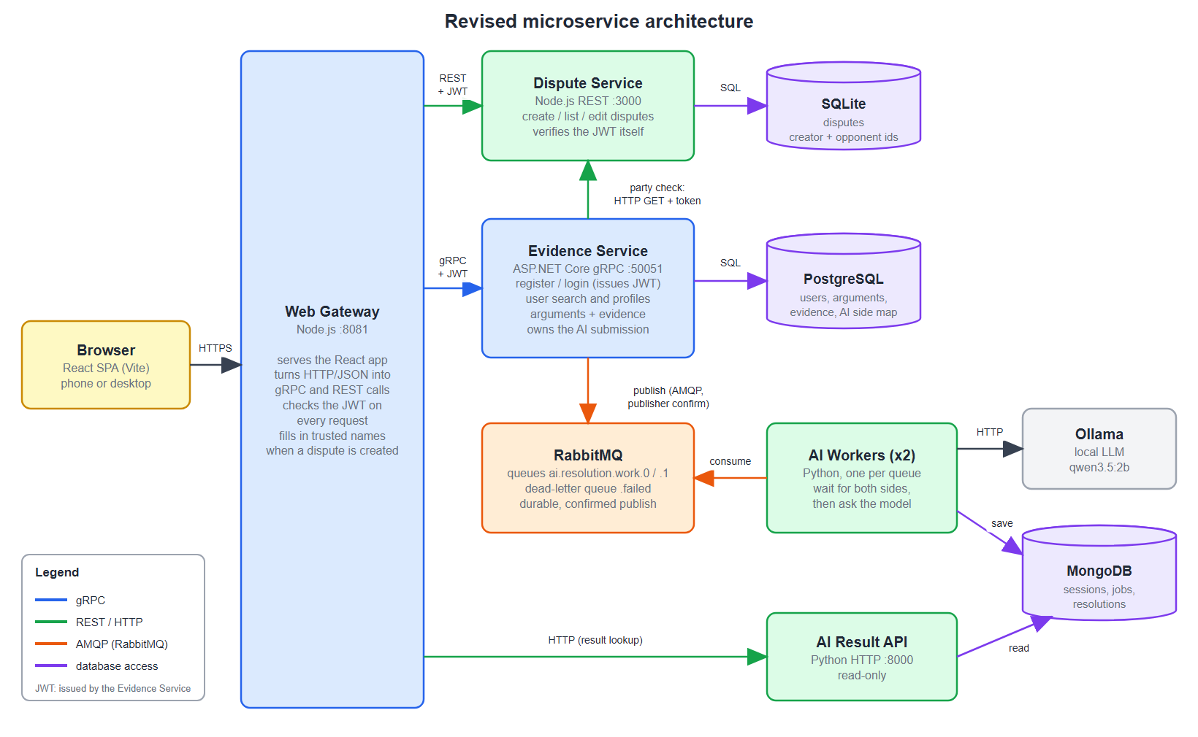
Figure 1: Revised microservice architecture.

3. Service Discovery
Services find each other by name. Docker Compose gives every service a name on its network, and Docker's DNS resolves that name to the container address, so no IP address appears in the code and a restarted container is still found. External API clients use one address, Kong, which routes by path to the same names. The routes are declared in kong/kong.yml and can be seen in the Kong Manager. The reasons and the limits of this choice are in ADR 6.
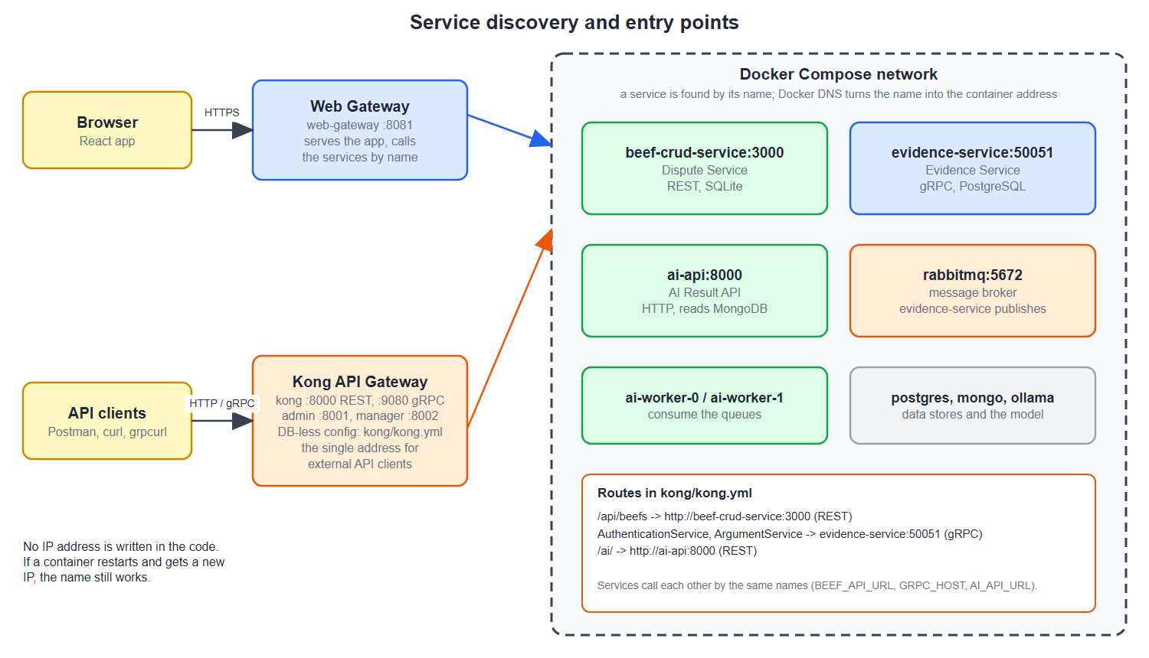
Figure 2: Service discovery and entry points.

4. How the Non-functional Requirements Are Managed
Requirement | How it is managed | Status
Availability (99% uptime) | Containers restart automatically. Health checks on PostgreSQL, MongoDB, RabbitMQ, Ollama and Kong, and services start in dependency order. Durable queues keep the AI work while a worker is down. | Partly: one instance per service, uptime not measured
Scalability (500 concurrent disputes) | AI work is spread over queues by dispute id, so more queues and workers can be added. The services keep their state in the databases, so they can be replicated behind Kong. | Designed, not load tested
Performance (AI within 5 seconds) | The AI call is asynchronous through RabbitMQ, so the user is never blocked and gets "queued" at once. Calls between services have a 3 second timeout. | Not met: the local model is slower than 5 seconds
Reliability | The broker confirms each publish, failed jobs go to a dead-letter queue and message ids make retries safe. Argument edits carry a version number. If the Dispute Service is down the Evidence Service answers UNAVAILABLE instead of saving unchecked data. | Implemented
Security | JWT on every service, salted PBKDF2-SHA512 password hashes, only the two people in a dispute can read or change it, and Kong is the single entry point for API clients. | Partly: no TLS and no encryption at rest yet
Operability | Health endpoints, the Kong Admin API and Manager, and the RabbitMQ management page show what is running and where messages are. | Implemented: no central logs or metrics yet

